Machine Learning Safety
Exercise Sheet 6
Question 6.1
What are advantages of explainable models in a safety-critical context? What are potential disadvantages or limitations of current explainability methods?
Answer
Explainability is important in safety-critical systems because it helps humans understand why a machine learning model made a particular decision. This can support certification and regulatory requirements, help identify biases, assist in debugging model errors, and increase trust in the system. For example, in autonomous driving, explainability can reveal whether a pedestrian detector is actually focusing on the pedestrian rather than irrelevant background features.
However, current explainability methods also have limitations. Explanations may appear plausible while not accurately reflecting the model’s true reasoning process. They can highlight correlated features instead of causal ones, and different explanation methods may produce different results. Furthermore, users may place too much trust in explanations that look convincing. Therefore, explainability should be considered supporting evidence rather than proof that a system is safe.

Question 6.2
Describe the difference between local and global explainability. Name one method for each kind and explain what question it answers.
Answer
Local explainability aims to explain why a model made a specific prediction for a particular input. It focuses on individual decisions and identifies which parts of the input were most influential. An example of a local explainability method is a saliency map, which highlights image regions that most affect the model’s prediction.
Global explainability aims to understand how a model behaves in general across many inputs. It focuses on the overall decision-making process and the features learned by the model. An example of a global explainability method is filter visualization, which shows what patterns activate specific filters in a neural network.
Therefore, local explainability answers the question “Why did the model make this particular prediction?”, while global explainability answers the question “How does the model generally make decisions?”
Question 6.3
Briefly describe the saliency method and the occlusion method. What is one advantage and one disadvantage of each compared to the other?
Answer
The occlusion method explains a prediction by covering different parts of an image and checking how the prediction changes. If covering a region causes a large drop in confidence, that region is considered important.
An advantage of occlusion is that it is easy to understand and works with many different models.
A disadvantage is that it is slow because the model must be run many times.
The saliency method explains a prediction by measuring how sensitive the prediction is to changes in each pixel. Pixels that have a larger effect on the prediction are considered more important.
An advantage of saliency maps is that they are much faster to compute.
A disadvantage is that the resulting explanations can be noisy and harder to interpret.
In summary, occlusion removes parts of the image and observes the effect on the prediction, while saliency measures how much each pixel influences the prediction.

Question 6.4
Modern LLMs often produce a thinking trace (chain of thought) alongside their answer
1. What does it mean for a thinking trace to be faithful? Why is faithfulness hard to verify?
Ans 1
A thinking trace is faithful if the explanation accurately reflects the model's actual reasoning process. The steps shown by the model should correspond to the computations that led to the answer. It is hard to verify that because we cannot directly observe the model's internal reasoning. We only see the input, output, and generated explanation, so it is difficult to know whether the explanation matches the true reasoning process.
2. What is simulatability as a measure of thinking-trace quality? Give an example scenario where simulatability is satisfied but the trace is still unfaithful.

Ans 2
Simulatability measures whether a human can predict the model's answer using the thinking trace. If the reasoning steps make it easy to determine the final answer, the trace has high simulatability.
Example where simulatability is satisfied but trace is unfaithful
Suppose an LLM answers a math problem correctly and provides a clear step-by-step solution. A human can easily follow the steps and predict the answer. However, the model may have guessed or memorized the answer first and generated the explanation afterward. In this case, the trace is simulatable but not faithful.

3. What does counterfactual simulatability add? Why is it a stricter test?
Ans 3
Counterfactual simulatability checks whether the reasoning trace still helps predict answers for related or slightly modified questions. It tests whether the trace contains genuine reasoning rather than simply explaining one specific answer.
It is stricter because a trace that merely explains the final answer may work for one question but fail when the question changes. A genuinely faithful reasoning process should remain useful under small changes to the problem.

4. Why does an unfaithful thinking trace pose a safety risk? Give one concrete example.
Ans 4
An unfaithful trace can make users trust a model for the wrong reasons. If the explanation looks convincing but does not reflect the real reasoning process, people may believe the system is reliable when it is actually using incorrect or unsafe features.
Example
A medical diagnosis model explains that it detected signs of a disease in an X-ray image. However, the model may actually be relying on irrelevant features such as a hospital watermark. Doctors may trust the explanation and make important decisions based on a model whose true reasoning is flawed.

Question 6.5
Choose one local explainability method from the lecture: occlusion, CAM, Grad-CAM, or saliency maps. Apply it to each of your three CARLA models.
1. Briefly describe how your chosen method works and why you chose it.
Ans 1
For this exercise, I chose the saliency map method. A saliency map explains a model’s prediction by highlighting the pixels that have the greatest influence on the output. It is computed using the gradient of the prediction with respect to the input image. Pixels with larger gradient values are considered more important because small changes to them would have a larger effect on the prediction.
I chose saliency maps because they are simple to implement, computationally efficient, and can be applied to all three CARLA models without modifying the network architecture. In addition, they provide an intuitive visualization of which regions of the image are most important for the model’s decision.

2. Select five correctly classified images- at least one per model. Visualize the explanation (heatmap or sensitivity map) overlaid on the original image.
3. Do the highlighted regions correspond to the relevant objects (e.g., does the map highlight the pedestrian when the model predicts “pedestrian present”)?
Ans 2 & 3
Image 1: Pedestrian Model – No Pedestrian Present
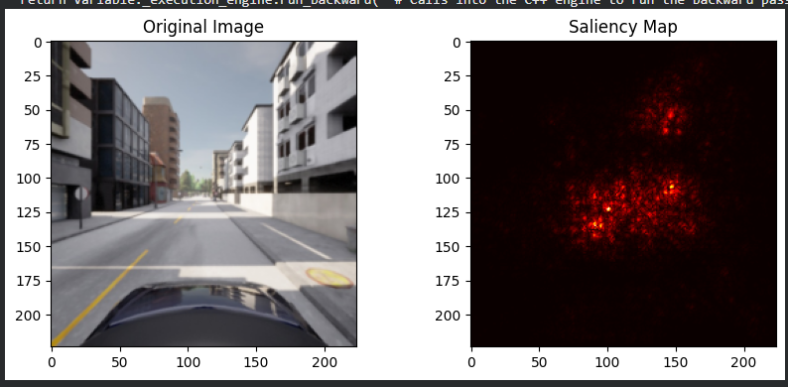
The image was correctly classified as not containing a pedestrian. The saliency map highlights parts of the road and the central region of the scene while giving less attention to irrelevant background areas such as the sky and distant buildings. Since no pedestrian is present in the image, the model appears to rely on general scene information to support its prediction. The explanation is consistent with the model’s decision and does not indicate a strong focus on any non-relevant object.
Image 2: Pedestrian Model – Pedestrian Present

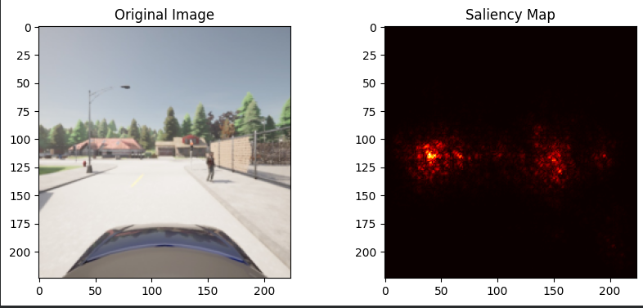
The image was correctly classified as containing a pedestrian. The saliency map highlights the region around the pedestrian and nearby road features. This indicates that the model is focusing on relevant information when making its prediction. Most of the attention is concentrated near the pedestrian rather than on unrelated background elements such as the sky, trees, or distant buildings. Therefore, the explanation is consistent with the model’s decision and suggests that the model has learned meaningful pedestrian-related features.

Image 3: Vehicle model – Vehicle Present
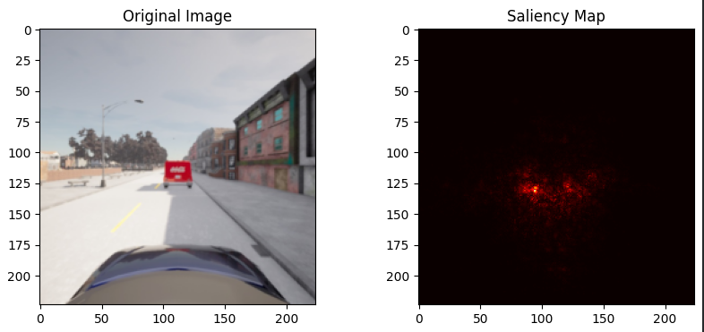
The image was correctly classified as containing a vehicle. The saliency map highlights the region around the red vehicle in front of the ego vehicle. This suggests that the model is focusing on the relevant object when making its prediction. Very little attention is given to unrelated background elements such as the sky, buildings, or trees. The explanation is therefore consistent with the task and indicates that the model has learned meaningful vehicle-related features.
Image 4: Vehicle Model – Vehicle Present
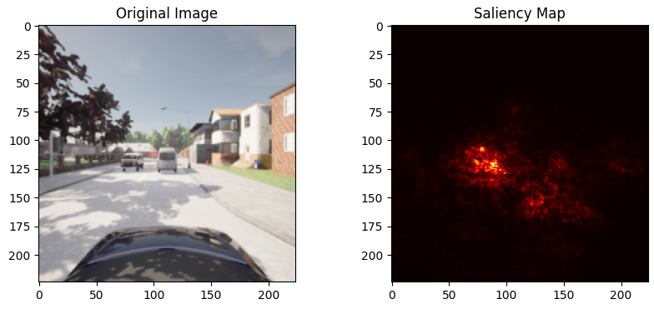
The image was correctly classified as containing a vehicle. The saliency map highlights the area around the vehicles in the centre of the image, particularly the white van and nearby vehicle regions. This indicates that the model is paying attention to relevant vehicle-related features when making its prediction. Background elements such as the sky, houses, and trees receive considerably less attention. The explanation is therefore consistent with the model’s prediction and supports the conclusion that the model has learned useful vehicle representations.
Image 5: Traffic light model – Traffic light Present
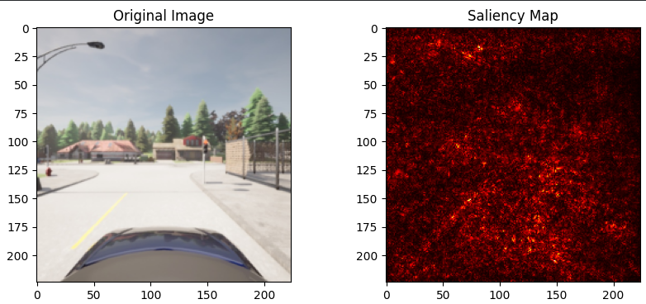
The image was correctly classified as containing a traffic light. However, the saliency map is considerably more diffuse than in the pedestrian and vehicle examples. While some attention appears near the traffic-light region, the model also highlights several surrounding areas of the scene. This suggests that the model may be using contextual information, such as nearby road and environmental features, in addition to the traffic light itself. The result also illustrates a known limitation of saliency maps, which can sometimes produce noisy and difficult-to-interpret explanations.

4. Select three misclassified images and apply the same method. Do the explanations give any insight into why the model failed?
Ans
Misclassified Image 1- Pedestrian Model

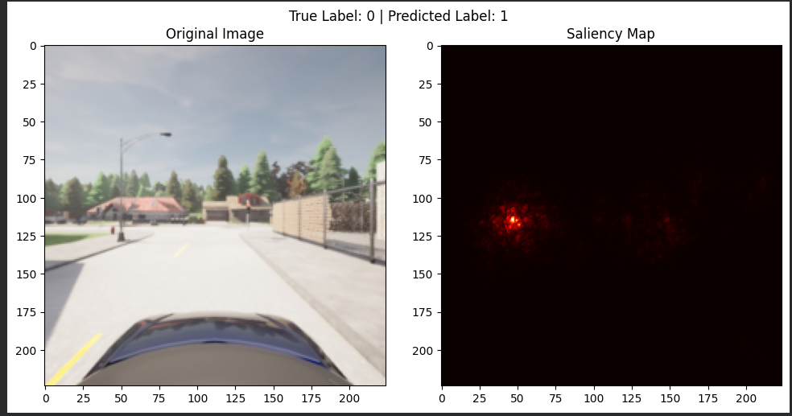
The image was incorrectly classified by the pedestrian model. The true label indicates that no pedestrian is present, while the model predicted the presence of a pedestrian. The saliency map shows that the model focuses strongly on a small roadside object on the left side of the image rather than on the central road region. This suggests that the model may have confused the object like pole with pedestrian-like features, leading to a false positive prediction. Therefore, the saliency map provides a plausible explanation for why the model made an incorrect decision.
Misclassified Image 2- Vehicle Model
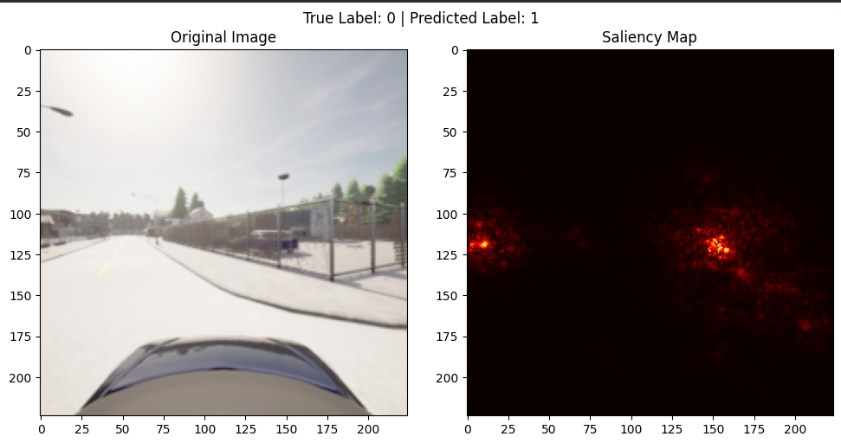
The image was incorrectly classified by the vehicle model. The true label indicates that no vehicle is present, while the model predicted the presence of a vehicle. The saliency map highlights roadside structures and fence regions rather than a clearly identifiable vehicle. This suggests that the model may have confused these object-like patterns with vehicle-related features. As a result, the model produced a false positive prediction. The saliency map therefore provides a reasonable explanation for the model’s failure.

Misclassified Image 3- Traffic light Model
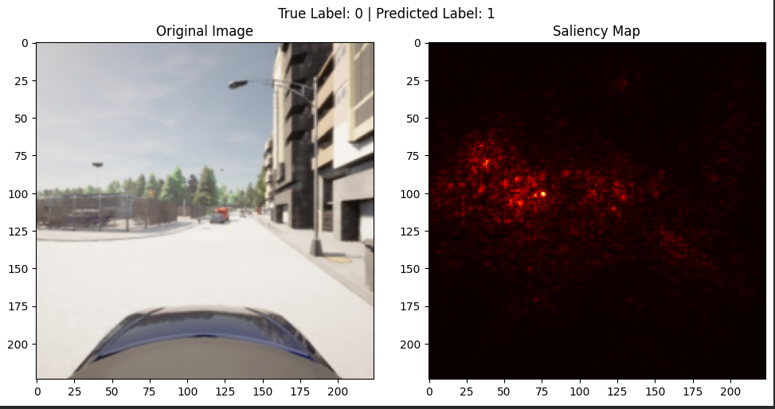
The image was incorrectly classified by the traffic-light model. The true label indicates that no traffic light is present, while the model predicted the presence of a traffic light. The saliency map highlights roadside structures, poles, and building regions rather than a specific traffic-light object. This suggests that the model may have confused these visual features with traffic-light characteristics, resulting in a false positive prediction. The explanation therefore provides a plausible reason for the model’s incorrect decision.

Question 6
1. Suppose your explanation method reveals that your model predicts “pedestrian present” based primarily on a region of the sky rather than the pedestrian itself. What would this imply about the model’s generalization? What could cause this behavior?
Answer
If the explanation method shows that the model predicts “pedestrian present” based mainly on a region of the sky rather than the pedestrian itself, this suggests that the model has learned an incorrect relationship in the data. Instead of focusing on the relevant object, it relies on background features that are not directly related to the task.
This would indicate poor generalization because the model may fail when applied to new environments where the sky looks different, such as at night, in fog, or under different weather conditions. The behavior is often caused by dataset bias or spurious correlations in the training data. For example, if pedestrian images frequently contain a particular sky appearance, the model may incorrectly associate that feature with the presence of pedestrians.

2. Now test your models on images from different conditions than the ones they were trained on- for example a different town layout, nighttime, or foggy weather. Apply the same explanation method as before.
a) Do the highlighted regions still correspond to the relevant objects?
Ans
Pedestrian Model
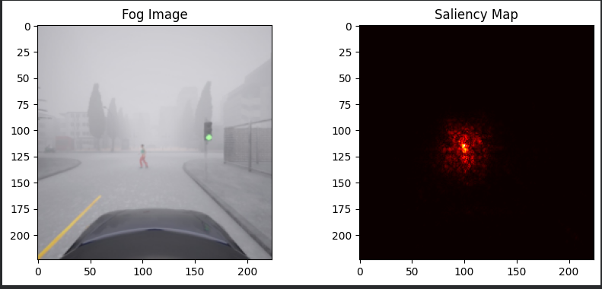
For the pedestrian model, the highlighted region still corresponds to the relevant object. The saliency map is concentrated around the pedestrian and nearby road area, indicating that the model continues to rely on pedestrian-related features even under foggy conditions. Although the image visibility is reduced due to fog, the explanation remains consistent with the prediction and highlights the correct region of interest.

Vehicle Model
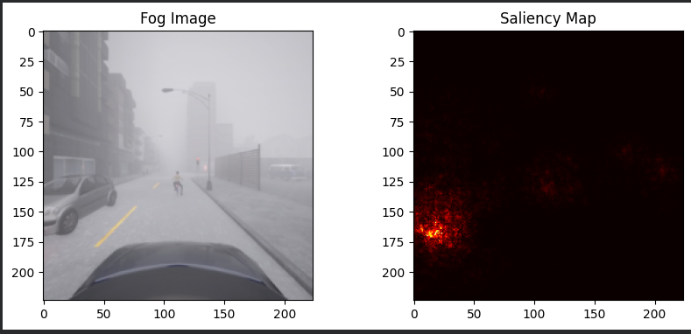
For the vehicle model, the highlighted region still corresponds to the relevant object. Despite the reduced visibility caused by fog, the saliency map focuses primarily on the vehicle region on the left side of the image. The model does not appear to rely heavily on unrelated background features such as buildings or the sky. Therefore, the explanation remains consistent with the prediction and indicates that the model is still identifying vehicle-related features under foggy conditions.

Traffic light Model
For the traffic-light model, the highlighted region still corresponds to the relevant object. Despite the reduced visibility caused by fog, the saliency map remains concentrated around the traffic-light region. The explanation is more focused than some of the normal-weather examples and indicates that the model continues to rely on traffic-light-related features when making its prediction. Therefore, the highlighted regions remain consistent with the target object even under different environmental conditions.

b) Do you observe evidence that the model relied on background or spurious features (lighting, road texture, sky color) that are specific to the original training conditions?
Ans
When comparing the saliency maps from the original test set and the foggy test set, there is limited evidence that the models rely heavily on spurious background features such as sky colour, lighting conditions, or road texture. In the normal-weather images, the pedestrian and vehicle models primarily focused on the relevant objects, and this behaviour remained largely unchanged in the foggy environment. Similarly, the traffic-light model continued to focus on the traffic-light region despite reduced visibility.
If the models had relied strongly on background features from the original training conditions, we would expect the saliency maps to shift toward fog, lighting effects, road texture, or other environmental features when tested on the fog dataset. However, the explanations remained centred on the target objects in most cases. Therefore, the results suggest that the models learned meaningful object-related features rather than depending primarily on condition-specific background cues.

c) How do the model’s accuracy and explanation quality change across conditions?
Ans
The model performance changed noticeably under foggy conditions. The pedestrian model achieved an accuracy of approximately 80.97%, while the traffic-light model achieved approximately 82.64%. Both models maintained relatively high performance and their saliency maps continued to focus on the relevant objects, indicating stable explanation quality across conditions.
In contrast, the vehicle model achieved an accuracy of only 44.19%, indicating a significant reduction in performance. Although the saliency maps still highlighted vehicle-related regions, the lower accuracy suggests that fog reduced the visibility of important vehicle features and made the classification task more difficult.
Overall, the explanations remained largely consistent across conditions, as the models continued to focus on the target objects. However, the vehicle model showed that explanation quality alone does not guarantee strong predictive performance, since the model could still attend to relevant regions while making less accurate predictions under challenging environmental conditions.

